Professional Identity
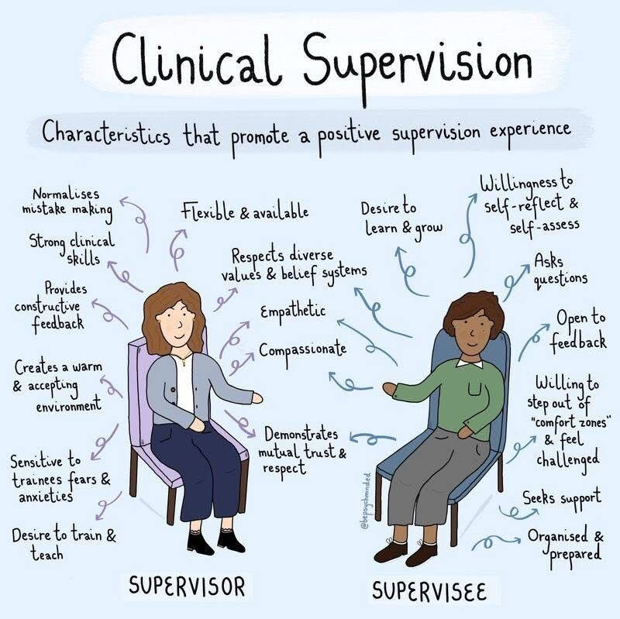

- As a counselor-in-training I review, comprehend and utilize the ACA Code of ethics on a regular basis to remain a competent provider (American Counseling Association, 2014, C.1.).
- I maintain my membership with American Counseling Association to maintain professional connections with other counseling providers and obtain additional training opportunities (American Counseling Association, 2014, C.4.f.).
- I utilize my clinical judgment to protect my clients and others. When I need confirmation and guidance with my clinical judgement, I contact my supervisors (American Counseling Association, 2014, C.2.e.).
- As a counselor-in-training I accept and understand the necessity of training, consultation and continued education to maintain knowledge on relevant practices and research.
- I will completing a continuing education course to apply as an associate professional counselor in law and ethics to ensure I am aware all of the legal responsibilities my role requires (American Counseling Association, 2014, C.2.f.).

References
American Counseling Association. (2014). 2014 ACA code of ethics.
https://www.counseling.org/docs/default-source/default-document-library/ethics/2014-aca-
code-of-ethics.pdf

