Acceptance
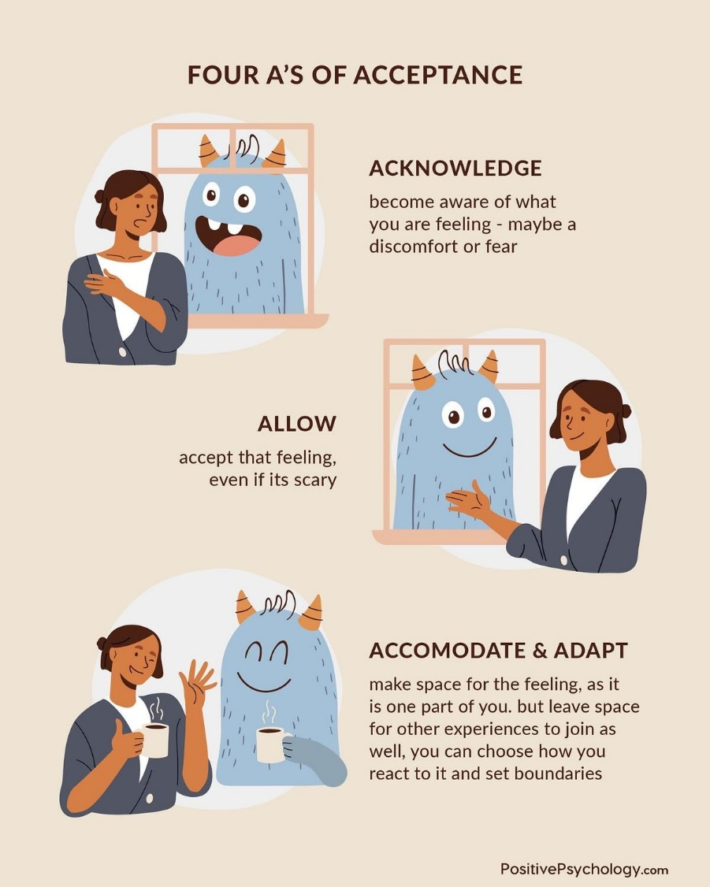

- Counselors in training must be aware of their beliefs and biases to avoid causing intentional or unintentional harm to their clients of all ages (American Counseling Association, 2014, A.4.a. & A.4.b.).
- I attend weekly supervision with my faculty supervisor and site supervisors to gain feedback and guidance in theory to best assist my clients’ needs. I seek clarification and insight from my superiors on evidence-based interventions and theories.
- I accept all of my clients within their functioning and capabilities. I identify their strengths and areas of weaknesses. Therapy is a process that requires empathy, patience and acceptance.
- As a counselor in training I am aware of my limitations within my scope of practice and ethical obligations with my clients.

References
American Counseling Association. (2014). 2014 ACA code of ethics.
https://www.counseling.org/docs/default-source/default-document-library/ethics/2014-
aca-code-of-ethics.pdf

