Empathy

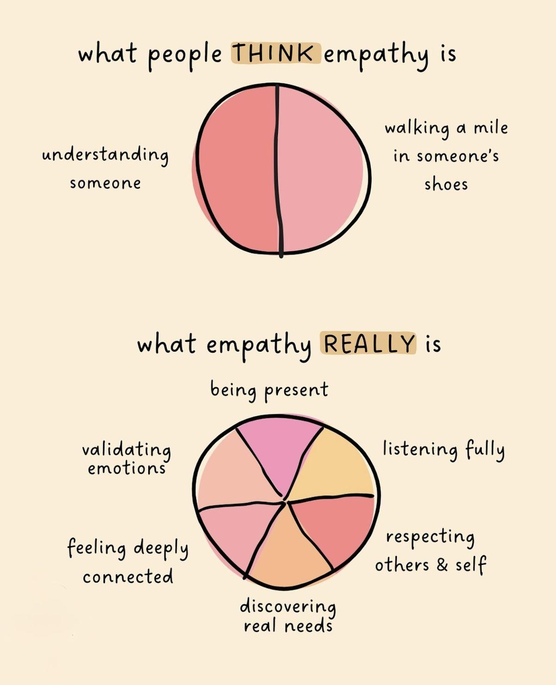

- As a counselor-in-training, I utilize empathy towards others' feelings, needs, desires, and life experiences.
- My values do not have a place in the sessions, and the focus is on the client to avoid causing harm (American Counseling Association, 2014, A.4.a.).
- I maintain healthy and respectful boundaries with peers, clients, and loved ones.
- Sessions are a designated safe environment to discuss any issues, feelings, or concerns.
- When my minor clients' parents do not speak the same language as I do, my site provides a translator to facilitate empathetic communication surrounding concerns, questions, and the treatment being provided (American Counseling Association, 2014, A.2.c.).

References

American Counseling Association. (2014). 2014 ACA code of ethics.

https://www.counseling.org/docs/default-source/default-document-library/ethics/2014-ac

a-code-of-ethics.pdf

