Cultural Diversity
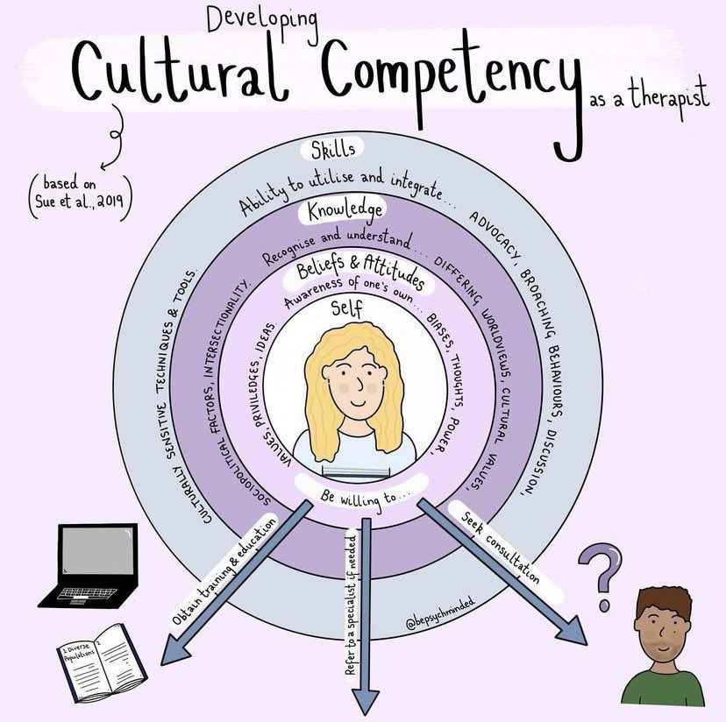
- Counselors in training must be aware of their own belief systems and values to avoid imposing or influencing their client’s treatment with biases (American Counseling Association, A.4.b.).
- The intake process requires the exploration and acknowledgment of client’s cultures and their connection with their traditions, values and norms.
- As a counselor in training, I acknowledge the cultural differences in the counseling relationship and create a safe environment to allow for questions or concerns.
- If at any point my cultural competence is not adequate enough, I would refer to another provider who is more suitable to assist the client with their therapeutic treatment (American Counseling Association, A.11.b.).
- I consider the client’s culture in the assessment selections and the diagnostic process to avoid causing unintentional harm (American Counseling Association, E.8.).
- I will continue to receive training in cultural diversity and utilize evidence-based interventions to treat all of my clients.

References
American Counseling Association. (2014). 2014 ACA code of ethics.
https://www.counseling.org/docs/default-source/default-document-library/ethics/2014-aca-code-
of-ethics.pdf

